|  |  |  |  |
| --- | --- | --- | --- |
| **Group No.** | **Group Members** | | |
|  | **ID** | **Name** |
| ? | 1. |  |  |
| 2. |  |  |
| 3. |  |  |
| 4. |  |  |
| 5. |  |  |
|  |  |  |

**Laboratory Experiment Report**

Electronic Drives Laboratory

Semester: Spring 2021-22

|  |  |  |
| --- | --- | --- |
| Experiment No. : |  | |
| Experiment Title : |  | |
| Date of Experiment: | | Date of Report Submission: |

**Marking Rubrics for Laboratory Report (to be filled by Faculty)**

|  |  |  |  |  |
| --- | --- | --- | --- | --- |
| **Objectives** | **Unsatisfactory (1)** | **Good (2-3)** | **Excellent (4-5)** | **Marks** |
| **Theory** | The relevant theories are not being described properly. | Part of the relevant theories are described with proper mathematical expression and circuit diagrams (if any) | All the relevant theories are included with proper descriptions, mathematical expressions and circuit diagrams. (if any) |  |
| **Simulation circuits & Results** | Simulation circuits are not included in this report. | Partial simulation circuit results are included in this report. | All the simulation circuits are included in this report with appropriate results. |  |
| **Report Question, Discussion on Comparison between theoretical and simulation results** | Cannot reach meaningful conclusions from experimental data; Cannot summarize or compare findings to expected results | Can extract most of the accurate data. Answers to the report questions are partially correct; Summarize finding in an incomplete way | Can extract all relevant conclusion with appropriate answer to the report questions; Summarize finding in a complete & specific way |  |
| **Organization of the report** | Report is not prepared as per the instruction. | Report is organized despite of few missing sections as per the recommended structure. | Report is very well organized. |  |
| **Comments** | Assessed by (Name, Sign, and Date) | | Total (out of 20): |  |

* The laboratory report must include the following 7 contents.

**(1) Experiment title:**

**(2) Objective of this experiment:** (max. 5 sentences)

**(3) Relevant Theory:** (any laws, circuit diagrams, mathematical expression etc. **in brief**)

**(4) Simulation circuits and Results:**   
 >>> add screen-shot(s) of different simulation circuits as instructed during lab experiment.   
 >>> add tables, graphs etc. as instructed during lab experiment by the instructor.  
  
Example: if you have worked on multiple simulation circuits in a lab experiment, follow the example below for preparing this section:

**Simulation circuit-1**

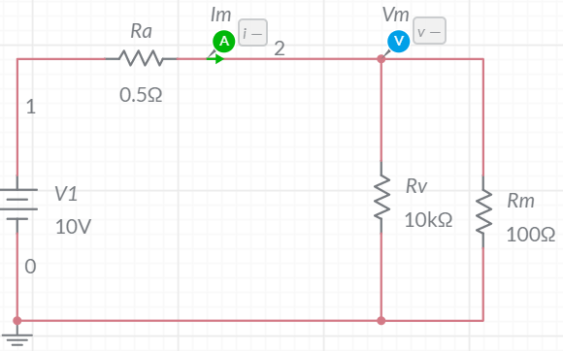  
Figure No. 1: Simulation circuit -1

Table No.1: Simulation results of circuit-1

|  |  |  |
| --- | --- | --- |
|  |  |  |
|  |  |  |
|  |  |  |

You must include additional results of simulation circuit no-1 such as Graphs   
(if needed/ instructed)

**Simulation circuit-2**

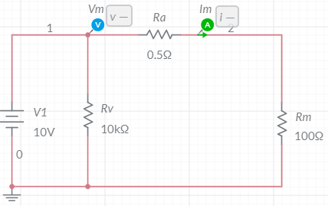  
Figure No. 2: Simulation circuit -2

Table No.2: Simulation results of simulation circuit -2

|  |  |  |
| --- | --- | --- |
|  |  |  |
|  |  |  |
|  |  |  |

You must include additional results of simulation circuit no-1 such as Graphs   
(if needed/ instructed)

**(5) Report Question:** (answer the report questions from experiment sheet or as instructed   
 during experiments)

**(6) Discussion:** (summary of understanding & observations of group members)

**(7) References:** (include a reference list as per IEEE referencing format)